Case 9-MEX-Colima-Tlaloc-Incensario-Terra cotta-200 BCE-200CE
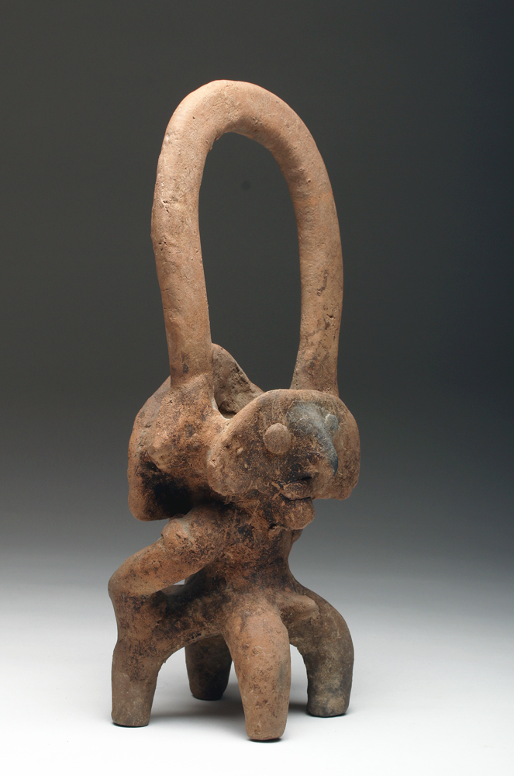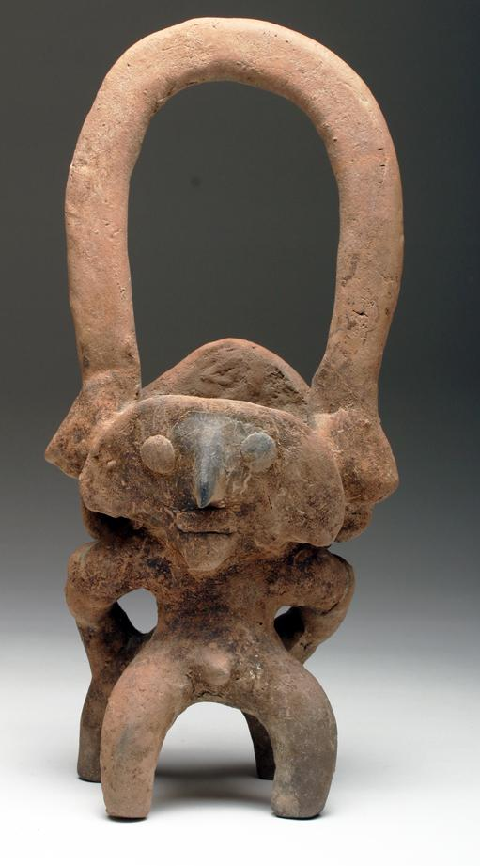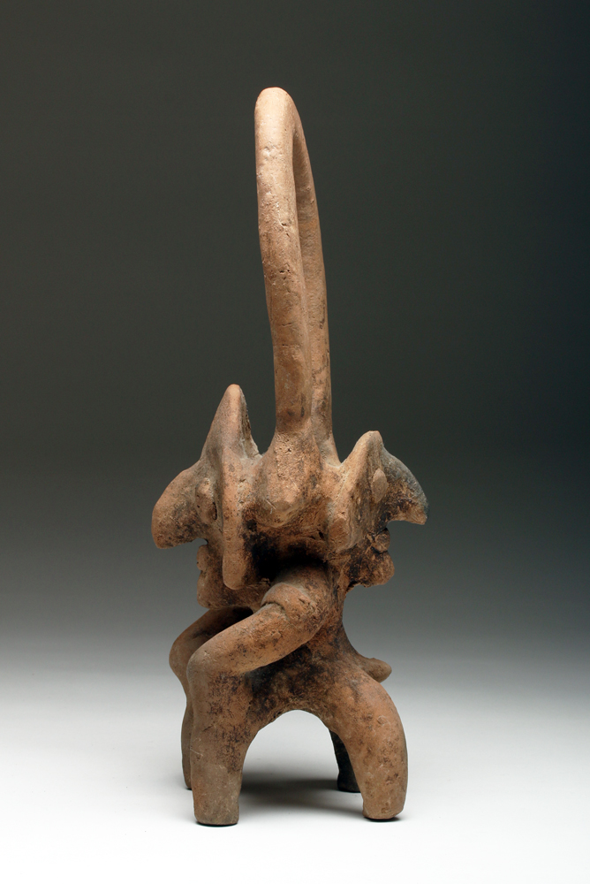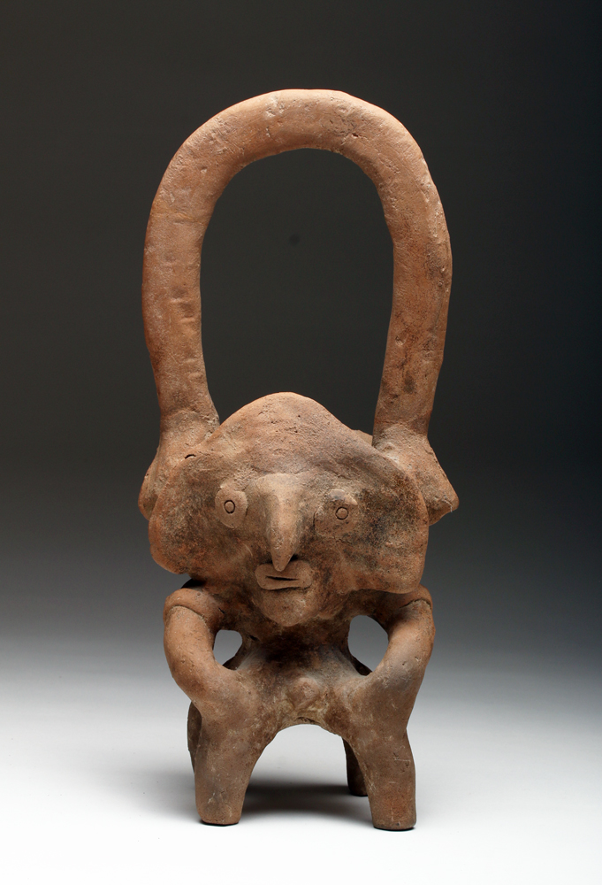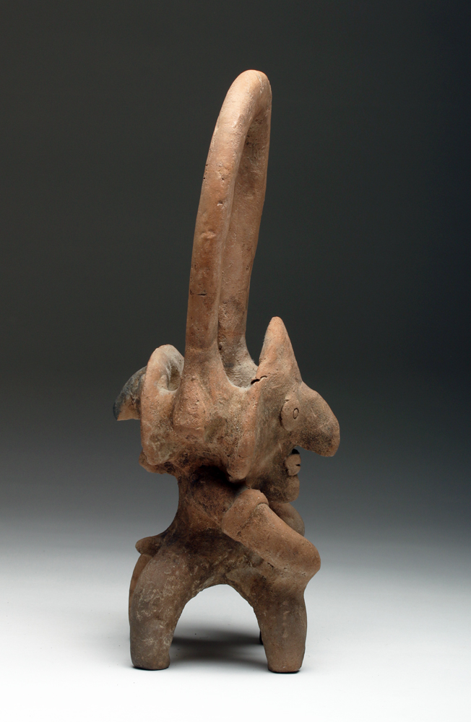
Case No.: 9
Accession Number:
Formal Label:
Display Description:
Colima Tlaloc Incensario from West Mexico, ca 100 B.C. - 250 A.D. Brown-buff terracotta brazier having opposing janeiform, male figures, each with prominent genitals and bold semiabstract facial features. Basket handle and the receptacle lies between the heads.
LC Classification:
Date or Time Horizon:
Geographical Area: West Mexico
Map:
GPS Coordinates:
Cultural Affiliation:
Medium: terra cotta
Dimensions: H 14 in
Weight:
Provenance: Ex-Laguna Niguel, CA collection acquired in the 1980's. Then Artemis Gallery, 107144.
Condition: A few invisible repairs to handle, encrusted surface
Discussion:
References:

Order details

Sales order
Sold by artemisgallery ( 637 )

Delivery package 1 of 1
Estimated delivery Tuesday, Feb 2, 2016
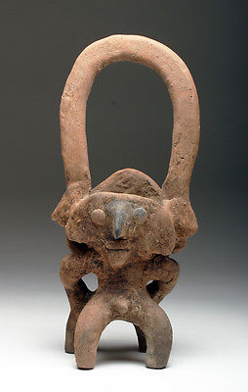

Colima Incensario in Form of Tlaloc
Item price | $595.00
Quantity | 1
Item number | 381258126822
Shipping service | UPS Ground

Shipping address

Ralph J Coffman Jr
149 Atlantic Ave
Swampscott MA 01907-2427
United States

Order total

Subtotal | $595.00
Shipping | $44.99
Total
$639.99

Order placed on
Monday, Jan 25, 2016
Payment method
PayPal
Payment date

